Effects of Asymmetric Rolling with Tilted Material Entry
on Texture and Mechanical Properties of Aluminium

D. Byrska-Wójcik¹, M. Ostachowska¹, J. Gibek², K. Wierzbanowski^{2*}, M. Wróbel¹,
R. Błoniarz¹, A. Baczmański², M. Kopyściański¹ and I. Kalemba-Rec¹

¹ AGH University of Krakow, Faculty of Metals Engineering and Industrial Computer ScienceFaculty of Metals Engineering and Industrial Computer Science, 30-059 Kraków, Poland
² AGH University of Krakow, Faculty of Physics and Applied Computer Science, 30-059 Kraków, Poland
* corresponding author; e-mail: wierzbanowski@fis.agh.edu.pl

Abstract
Asymmetric rolling texture of aluminium alloy 1050 was examined both experimentally and numerically. The rolling asymmetry was realized using rolls with different diameters rotating with the same angular velocity and by varying inclination of the rolling strip (i.e., the flat and tilted entry of the rolled strip between rolls). The final, 84% reduction in the thickness was obtained after six consecutive rolling passes. Crystallographic texture variation over the rolled bar thickness was determined using X-ray diffraction and predicted using the Finite Element Method combined with two crystalline deformation models (i.e., the elasto-plastic and the elasto-viscoplastic ones). Textures predicted by both models, taking into account all deformation process parameters, are in good agreement with experimental results. The obtained results confirm the effect of texture modifications caused by the shear stress component, resulting in the shifts of selected texture maxima in the orientation space, and explain the observed texture distribution across the sample depth.
The novelty of this work consist in examination of the role of the tilted material entry (besides a difference in rolls diameters) in homogenization of texture distribution in multi-pass asymmetric rolling. The rolling geometry process variants, recommended for the technological practice, are indicated.

Key words:
Asymmetric rolling; Crystalline deformation models; Texture; Finite element method; X-ray diffraction

- Introduction

The development of crystallographic texture is one of basic effects of plastic deformation. The texture involves the anisotropy of material properties (elastic, plastic, magnetic, …) and depends on the symmetry both of the crystal and the deformation process. The classical rolling process is characterized by orthorhombic symmetry and therefore the crystallographic texture of the rolled material has this symmetry. In contrast, a lower process symmetry characterizes the asymmetric rolling (i.e., monoclinic symmetry). This technique offers some advantages and, it becomes now popular and starts to be used in industry (reviews can be found in [1], [2]). Asymmetric rolling can be realized by: (i) the difference in friction coefficients between the cooperating rolls and the rolled material, (ii) the difference in the rolls diameters or of their angular velocities, (iii) and by varying the rolling strip inclination, or by a combination of the above ones. The first method is difficult to control precisely. The second one, which is the easiest to implement in practice, is most frequently reported in the literature. The third method was previously used in cold rolling of thin sheets in multi-stand mills to reduce the length of the production line, but the effect on the properties of the rolled material was not analysed. To the best our knowledge, the beneficial effect of the rolled strip inclination on the product properties was examined and patented by D. Bozkaya and P.R. Jepson from H.C. Starck Inc., Newton, MA, US [3].
The asymmetric rolling refine grains [4] and produces more homogenous distribution of the microstructure (e.g., in copper [5], in magnesium [6], or in IF steels[7]) and crystallographic texture (e.g., [8][9]) over the product thickness and in this way it can improve some utility material properties, such as the mechanical properties [10] and formability [11][12]. It is interested to note that the results of this process depend also on temperature [13][14] and a comprehensive review of this effect can be found in [15]. Also, a combination of cross-rolling [16] and asymmetric rolling can be used to enhance the magnetic behaviour [17] or texture modification [18]. Moreover, this technology offers some economic and technological advantages. For example, the rolling normal force and rolling torques can be lowered in asymmetric rolling process as compared to the symmetric one [19]. This effect can also be used to increase productivity and to extend the rollers service life [20]. An interesting effect is that asymmetric rolling, combined with solution heat treatment can retard the recrystallization [21]. However, the asymmetrically rolled material may be bent [22]. This presents some inconvenience, but it can be controlled by an appropriate choice of rolling process parameters [23][24]; for example in [25] multi-pass asymmetric rolling routes considering bending optimization were proposed to obtain final plat plates. Also, uneven wear of the cooperating rollers requires proper management. However, the advantages of the asymmetric process far outweigh these drawbacks. So, it is no surprise that asymmetric rolling attracts the attention of metallurgists and material scientists, especially in the last years. Reports are available on testing applications of this technology for metals and alloys with different crystal structures, e.g., aluminium [26], steel [27][28] , magnesium [6], titanium [29], copper [30], zinc [31], invar [32] or even bimetallic sheets [33]. Some combination of symmetric and asymmetric rolling has been proposed and as shown, it also can modify the rolled material microstructure and texture (e.g., [34][35]). However, to our knowledge, the combination of different methods to induce rolling asymmetry has not been tested before. Thus, in the present work the effects of different diameters of rolls (turning with the same angular velocity) and the material strip tilting were examined. The study of multi-pass asymmetric rolling is another novelty of the present work. Thus, the comparison of texture heterogeneity, developed on the rolled bar thickness during multi-pass asymmetric and symmetric rolling, with its flat or tilted entry between rolls (shortly with flat or tilted entry), is the main goal of the present study. The experimental results are compared with these obtained by computer simulation of the deformation process using the Finite Element method (FEM) combined with two different crystalline deformation models. The first one is the crystal elasto-plastic model (CEP) developed by Leffers and Wierzbanowski [36][37]. The second is the crystal elasto-viscoplastic model (CEVP) developed by Marin and Dawson [38], [39]. Comparison of textures predicted by these two models for the same stress/strain field evolution obtained from FEM can be considered as a methodological goal.

- Experimental
The set of aluminium A1050 samples was rolled symmetrically and asymmetrically. The rolling was applied on the quarto rolling mill - Fig. 1. The angular speed of both rollers was equal to 21 rpm.

Fig. 1. The rolling mill used in experiments.

The rolling asymmetry was induced by different diameters of rolls cooperating with each other and turning with the same angular velocity (i) and by the tilted entry of the sheet (ii). The realized rolling variants are collected in Tab. 1. The samples were rolled until a final rolling reduction in thickness of 84%, obtained in six consecutive passes. The same partial reduction sequence, collected in Tab. 2 was applied in each rolling variant. The rolling asymmetry parameter A= d₂/d₁ and the tilting angle (α) of the sample insertion into the rolling gap (Fig. 2) characterized the applied asymmetry.
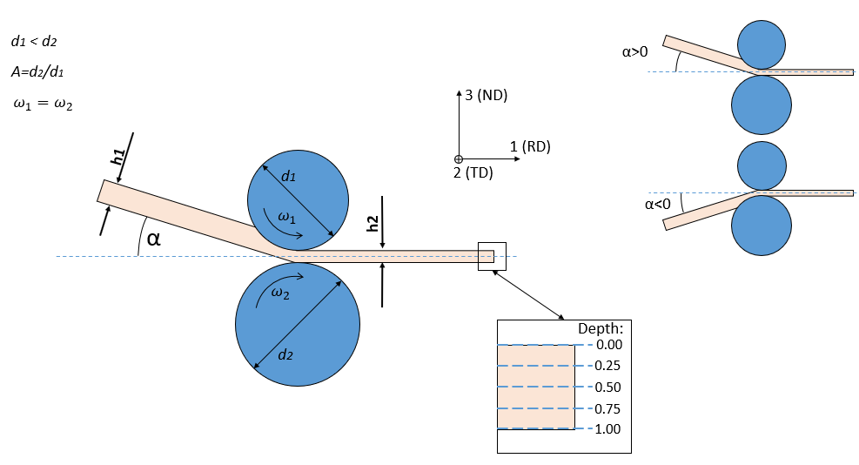
Fig. 2. Scheme of asymmetric rolling, using the same angular velocity and different roll diameters; α defines the angle of material entry into the rolling gap. Sites in the sample, defined as normalized depth (changing from 0.0 to 1.0), where textures were examined, are also shown. RD, TD and ND are rolling, transverse and normal directions, respectively.

Table 1. Parameters defining rolling variants.
No. of the rolling variant | $d_{1}$ [mm] | $d_{2}$ [mm] | $$A=\frac{d_{2}}{d_{1}}$$ | $α$ [°]
1 | 100 | 100 | 1.0 | 0
2 | 100 | 100 | 1.0 | +30 (up)
3 | 100 | 120 | 1.2 | 0
4 | 100 | 120 | 1.2 | +30 (up)
5 | 100 | 120 | 1.2 | -30 (down)

Table 2. Distribution of rolling reductions in successive passes in each rolling variant.
No of rolling pass | Rolling reductions, in consecutive passes [%] | Total rolling reduction after a given rolling pass [%]
1 | 15.5 | 15.5
2 | 19.2 | 31.6
3 | 21.1 | 46.1
4 | 28.2 | 61.3
5 | 29.1 | 72.5
6 | 42.5 | 84.0

The X-ray diffraction was used for determination of the {111}, {200}, {220} and {311} incomplete pole figures. The measurements were performed on the Pan Analytical Empyrean diffractometer using Cu Kα radiation. The LaboTex software [40] [41] (cf. also [42]) was used for the calculation of the orientation distribution function (ODF). The ODF is expressed in the Euler space with Euler angles according to Bunge convention [43]. Lack of the sample symmetry and cubic crystal symmetry were assumed in calculations, which resulted in the following ranges of Euler angles used for texture representation: $0°≤φ_{1}≤360°$, $0°≤≤90°$ , $0°≤φ_{2}≤90°$.
The microstructure of the rolled material was strongly heterogeneous. This is illustrated on the EBSD maps, where the deformation zones along the rolling direction (RD) are visible - Fig. 3. Therefore, it was expected that not only microstructure, but also the resulting deformation textures can vary inside the sample.
A=1.0 α=0° | A=1.0 α=30°
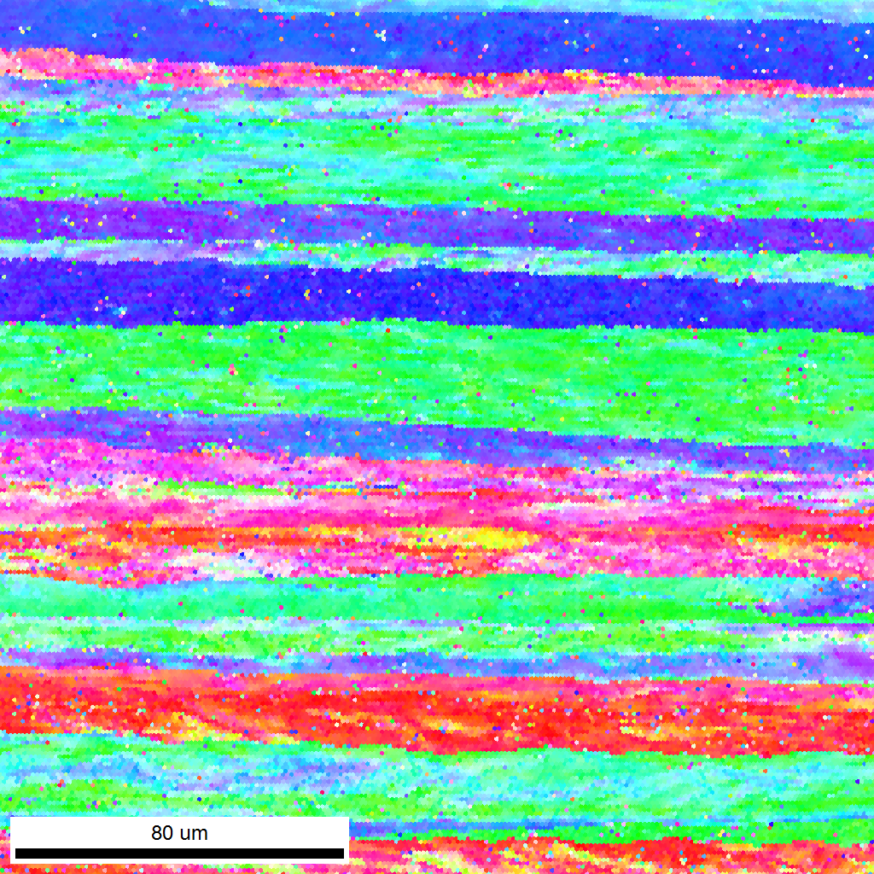 | 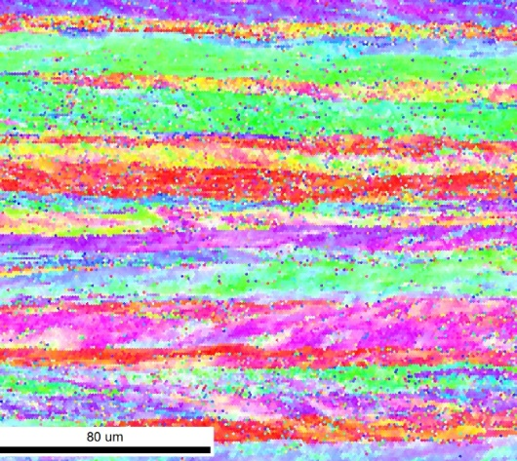 | 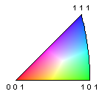
Fig. 3. The inverse pole figure distribution of ND for two example rolled samples: A=1.0 with flat (α=0°) and tilted (α=30°) material entries. The horizontal direction is parallel to RD.

To determine texture heterogeneity, the diffraction measurements were carried out in the middle of the rolled strip width at five depths (sites) evenly distributed along normal direction (ND) - Fig. 2. The normalized depth parameter was used: depth ‘0’ corresponds to the upper sample surface, depth ‘0.5’ to half of the sample thickness and depth ‘1’ to the lower sample surface. To enable these measurements, the consecutive layers of the material were gently mechanically removed and etched to get rid any possible deformed layer caused by the preparation.

- Texture simulation method
Metals deformed in asymmetric rolling exhibit generally microstructure and texture heterogeneity, and consequently the FEM analysis is necessary to determine the local stress and strain fields; a review on this subject can be found in [44]. The next step is coupling a crystal plasticity models with the FEM software (e.g., [45][46]).
The computer model of the multi-pass rolling accurately reflecting the performed experiment (i.e., materials, geometry, and kinematics) was built in the present work and used for the FEM calculation of the stress/strain field evolution using the commercial Abaqus software (version 2022). The FEM calculated stress/strain fields evolutions were used as boundary condition in the crystalline deformation models (CEP and CEVP) to predict the crystallographic texture development in the same layers of the rolled strip where the textures were measured.

3.1. FEM simulation of the rolling process
The first stage of computations was FEM modelling of the rolling process in macro scale. Each variant of the rolling process (for a given rolling asymmetry A and a selected angle of the sample tilting α) was simulated independently. One simulation consisted of six steps corresponding to six passes of the material through the rolling gap. After each simulated rolling pass a set of parameters (distribution of stresses and strains and deformed mesh) was transferred into a next pass as the initial state. Due to a high a computational cost, the rolling strip symmetry (i.e., the mirror symmetry plane perpendicular to TD located in the middle of the rolled strip) was used and the sample was shorter than in experiment. This simplification had no influence for accuracy of the calculations. The example mesh used in the simulation of the rolling variant with asymmetry A=1.2 and tilt angle equal to 30° is presented in Fig. 4a.
a | b
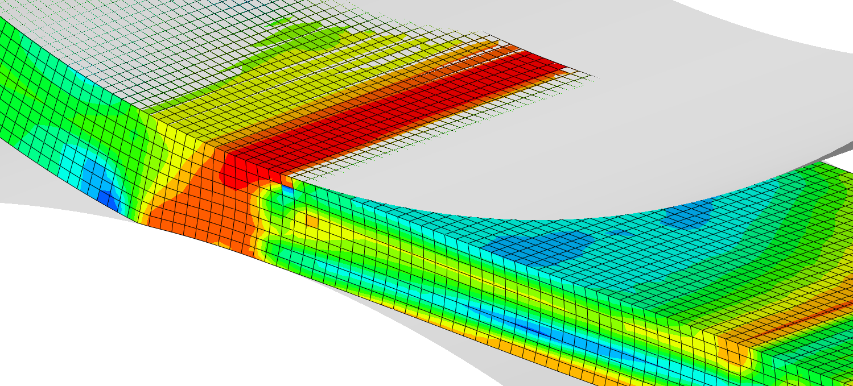 | 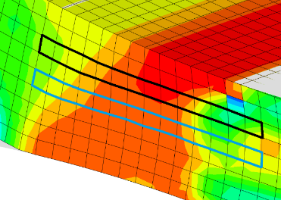
Fig. 4. a) Finite element mesh used in macro scale simulations of the rolling process with A=1.2 and α=30º (spatial distribution of Von Mises equivalent stress is shown), b) sites where the stress/strain values were red and transferred to the crystalline models: sites for depth 0.25 are marked in black and sites for depth 0.50 are marked in blue.

During simulation, it was assumed that the rolls were rigid bodies that did not deform plastically. This reflected the difference in their hardness and the hardness of the rolled aluminium strip. The friction coefficient μ=0.3 between the rollers and the rolled material was used. FE mesh covering aluminium sample consisted of 59 010 elements of the type C3D8R (Eight-node brick element with reduced integration). The stress/strain fields evolution calculated for the examined six rolling passes were used as the boundary conditions in crystalline deformation models. For the CEP model the local values of stress and for CEVP model those of strain were used. Numerical values of stress/strain fields evolution during rolling were red from integration points of the selected elements in the rolling gap. For example, for the site 0.25 these values were obtained from integration points of the elements marked in black, and for the depth 0.5 – from those marked in blue (see Fig. 4b).

3.2. Crystalline deformation models used
The description of polycrystalline sample deformation requires knowledge of the relationship between global (sample) variables, e.g., stress and strain, and analogous quantities relating to a single crystallite (Fig. 5). A full and strict analytical solution of this relationship is not currently possible, but this relationship can be approximated using some deformation models. There is a wide spectrum of such models, which were developed and based on: visco-plastic approach [47], [48], elasto-plastic one [49][50], formalism based on fast Fourier transform [51], dislocation based models [52][53] or statistical crystal plasticity approach [54]. Two models used in this work are briefly described below. In both models, the glides on <110> {111} slip systems (basic plastic deformation mechanism in aluminium) were considered, and a polycrystalline sample contained 1000 grains was used for texture predictions.

3.2.1. Crystalline elasto-viscoplastic model (CEVP)
Majority of the results presented in this work was obtained using the CEVP model developed by Marin and Dawson . The UMAT subroutine of Abaqus software for this model was created [55] and is available [56]. This is the constitutive model based on an advanced mathematical formulation and it was developed to describe the isothermal, quasi-static, large deformation of polycrystalline metallic materials. The used equations are derived for finite elasticity and then adopted to the case of small elastic strains. The extended Taylor hypothesis was used, according to which each grain is assumed to experience the macroscopic deformation – cf. Fig. 5. The described model can be used to predict the results of mechanical tests, crystallographic textures, and internal stresses development during high elasto-plastic deformations. To see details of mathematical formalism of this approach the Reader is referred to the original papers of its authors. However, some important assumptions of the model are recalled below.
The used CEVP model belongs to the wide family of Crystal Plasticity theories (e.g., [57], [58]. A comprehensive review of multiscale methods in crystal plasticity finite-element modelling is presented in [59]. In this approach the basic quantity is the deformation gradient tensor F (see e.g., [60][61]). It can be decomposed in a multiplicative way into two parts, elastic $F^{e}$ and plastic $F^{p}$ ones:
$F=F^{e }∙F^{p}$. (1)
The plastic deformation evolves as:
${\dot{F}}^{p}=L^{p}F^{p}$. (2)
If plastic deformation occurs only by crystallographic slip, $L^{p}$ (tensor of plastic velocity gradient) can be defined as the sum of shear rates on all active slip systems:
$L^{p}=\sum_{k=1}^{n}{{\dot{γ}}^{k}m^{k}⊗n^{k}}$, (3)
where $m^{k}$ and $n^{k}$ denote unit vectors of the slip direction and the slip plane normal of system k, respectively $n$ is the number of active slip systems, and $⊗$ denotes the dyadic product of vectors.
In the considered model the equations are expressed in the relaxed configuration $\hat{B}$ obtained by elastically unloading to a stress free state [39] .
The plastic velocity gradient ${\hat{L}}^{p}$ (eq. 3) can be decomposed into symmetric (strain rate) and skew-symmetric (spin) parts:
${\hat{L}}^{p}={\hat{D}}^{p}+{\hat{W}}^{p}$ . (4)
These quantities are expressed as follows:
${\hat{D}}^{p}=\sum_{k=1}^{n}{{\dot{γ}}^{k}({\hat{m}}^{k}⊗{\hat{n}}^{k})_{S}}$ , (5)
${\hat{W}}^{p}=\dot{R}∙R^{T}+\sum_{k=1}^{n}{{\dot{γ}}^{k}({\hat{m}}^{k}⊗{\hat{n}}^{k})_{A}}$ , (6)
where $R$ is the lattice rotation tensor, ${\hat{m}}^{k}$ and ${\hat{n}}^{k}$ are slip direction and slip plane normal, both expressed in the $\hat{B}$ relaxed configuration and S and A subscripts denote symmetric and asymmetric parts of tensors. The resolved shear stress $τ^{k}$ acting on the k slip system, in the case of isotropic elasticity and relatively small elastic strains $ε$ (as it is in the case of metals), can be calculated as:
$τ^{k}=τ{(m}^{k}⊗n^{k})_{S}$ , (7)
with: $τ=2με+ tr(ε)I$ , where λ and μ are Lamé constants and I is the second order identity tensor and symbol: means the scalar product of two second order tensors.
The phenomenological constitutive models define the shear rate ${\dot{γ}}^{k}$ as the function of the resolved shear stress $τ^{k}$ and critical resolved shear stress $τ_{c}^{k}$ as a state variable of slip system k. In the presented model the rate of shearing on the k slip system is calculated using the power law:
$${\dot{γ}}^{k}={\dot{γ}}_{0} {\left[\frac{τ^{k}}{g^{k}}\right]}^{\frac{1}{m}}sign\left(τ^{k}\right),$$ | (8)
where ${\dot{γ}}_{0}$ is a reference shear rate, $τ^{k}$ is the resolved shear stress on the k slip system, m is the rate sensitivity of slip and $g^{k}$ is the slip system hardness. The latter one can be identified as the critical shear stress ($τ_{c}^{k}$) and defined by the saturation type equation:

${\dot{g}}^{k}=h_{0}\left(\frac{g_{s}\left(\dot{γ}\right)-g^{k}}{g_{s}\left(\dot{γ}\right)-g_{0}}\right)\dot{γ}$ with $g_{s}\left(\dot{γ}\right)=g_{s0}{\left(\frac{\dot{γ}}{{\dot{γ}}_{s0}}\right)}^{m'}$, | (9)
where $\dot{γ}=\sum_{k}{\left|{\dot{γ}}^{k}\right|}$ is the total shear strain rate within the crystal, and $h_{0}, g_{s0}$, $g_{0},{\dot{γ}}_{s0} , m'$ are slip system hardening parameters which are identical for all slip systems. The values of these parameters were tuned to well reproduce the tensile curves measured experimentally. In the present calculations these parameters were equal to: $m=0.05$, ${\dot{γ}}_{0}=1.0 s^{-1}$, $h_{0}=200.0 MPa$, $g_{0}=210.0 MPa$, $g_{s0}=330.0 MPa$, $m^{'}=0.005$, ${\dot{γ}}_{s0}=5×{10}^{10}{ s}^{-1}$ [39]. In this approach it is assumed that all slip systems harden together at the same rate.
The lattice rotation R can be calculated according to Eq. 6. Finally, discrete sets of final grain lattice orientations were used to calculate the continuous functions of crystal orientation distributions (ODFs).

3.2.2. Crystalline elasto-plastic model (CEP)
To compare the predictions of the above formalism with another model, a simple crystalline elasto-plastic model (CEP) was used [36][37] . Basic relation between global and local stress and strain tensors is depicted in Fig. 5. Assuming isotropic elasticity and considering only the plastic part of deformation, this relation can be simplified as:

$$\dot{σ}=\dot{}+L\left({\dot{E}}^{p}-{\dot{}}^{ p}\right),$$ | (10)
where Σ is stress applied to the considered FEM element (sample), $E^{p}$ is the plastic strain of the sample, σ and ${}^{ p}$ are analogous quantities for a grain [36][37]; L=αG, where G is shear modulus and α describes elasto-plastic interaction between a grain and surrounding material (it varies between 0.01 and 0.1) [49]. The resulting value of L=800 MPa was chosen, which gives a good fit with experimental data obtained from mechanical tests. This value is distinctly lower than typical elastic constant (e.g., shear modulus), because stress relaxation processes occur at grain boundaries, and they reduce grain-material interaction [36][49]. We denote such the model as crystalline elasto-plastic (CEP) one.
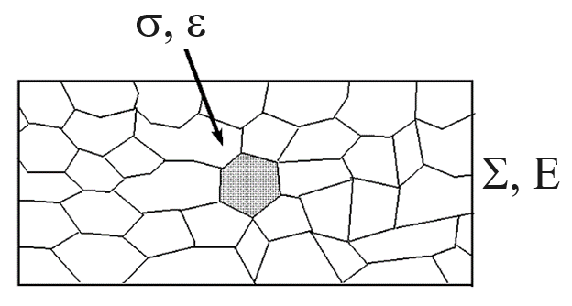
Fig. 5. The basic problem in modelling deformation of polycrystals: what is the relation between macroscopic ($E,$) and local ($ε, σ$) variables?

The resolved shear stress $τ^{k}$ on the slip system defined by its plane $n^{k}$ slip direction $m^{k}$ was calculated as:

$$τ^{k}=σ{(m}^{k}⊗n^{k})_{S}$$ | (11)
where $σ$ was obtained from Eq. 10. A given slip systems is activated when its resolved shear stress attains the critical value $τ_{c}$ (Schmid law [62]). Experimental observations show that the value of $τ_{c}$ increases due to the strain hardening. For a moderate increase in strain, the linear relationship between the critical resolved shear stress rate $\dot{τ_{c}^{k}}$ on the system k and the rates of slip shears on active sip systems, $\dot{γ^{l}}$, can be assumed:

$\dot{τ_{c}^{k}}=\sum_{l=1}^{n}{H_{kl}\dot{γ^{l}}}$ , (12)
where n is the number of active slip systems and $H_{kl}$ is the hardening matrix. In the present calculation the isotropic hardening matrix, with amplitude $h_{o}=100 MPa$ was used, which is a good approximation for aluminium. The plastic strain rate was calculated with the same formula as in the case of CEVP model (Eq. 5). The crystal lattice rotation R of a grain was calculated assuming that the orientations of the material string parallel to the rolling direction (RD) and of the material plane parallel to the rolling plane (defined by ND) must be preserved [36][63]. Similarly, as in the case of CEVP model, the obtained set of final grain lattice orientations was used to calculate the continuous function of crystal orientation distribution (ODF), which fully characterizes the predicted texture.

- Results

The final textures (obtained after six successive passages) that were examined both experimentally and theoretically, depend on the stress /strain field evolution during rolling. The latter were calculated by the applied FEM procedure. Let us briefly present selected results.
According to the maximum distortion energy criterion the continuous ductile materials begin to yield under multiaxial loading when the von Mises equivalent stress [64] reaches the critical value. This stress can be expressed as:
$\overline{}={\left[\frac{1}{2}\left\{{\left({}_{11}-{}_{22}\right)}^{2}+{\left({}_{22}-{}_{33}\right)}^{2}+{\left({}_{33}-{}_{11}\right)}^{2}\right\}+3\left\{{}_{12}^{ 2}+{}_{23}^{ 2}+{}_{31}^{ 2}\right\}\right]}^{\frac{1}{2}}$, | (13)
where ${}_{ij}$ are components of the stress tensor. The example spatial distribution of von Mises stress in the rolled material is shown in Fig. 4. This result corresponds to the case of asymmetric rolling with the inclined entry of the rolled material into rolling gap (A=1.2 and α=30º). As can be seen, the stress distribution is unsymmetrical with respect to the (RD-ND)-surface situated in the middle of the rolled strip thickness.

The distributions inside the rolling gap of three selected stress components (${}_{11}, {}_{33}$ and ${}_{13}$) for the examined deformation variants (listed in Table 1) are shown in Fig. 6. These components play a crucial role in texture rotation and heterogeneity. It can be noted that, except the case A=1.0, α=0°, the stress components are unsymmetrical with respect to the horizontal symmetry surface of the rolling gap. The asymmetry of stress distribution is especially visible in the cases of A=1.2.

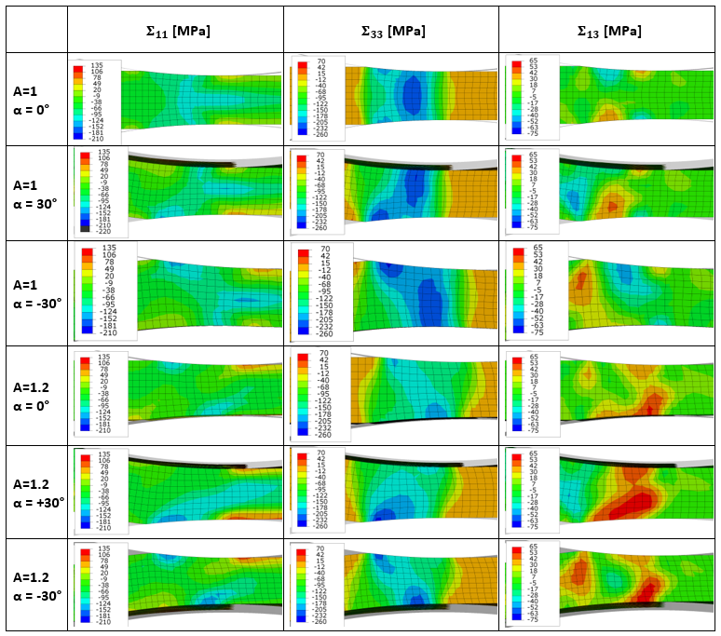
Fig. 6. Example stress distribution in the rolled material in the cases of A=1.0 and A=1.2 with entry angles of α=0º, α=30º and α=-30º. RD is in horizontal position.

The variations of individual stress components vs. normalized rolling gap length for three sites in the samples, during the first rolling pass, are shown in Fig. 7. The results for A=1.0 and A=1.2, with α=0º, are presented. The stress components are expressed in the rolling reference frame, i.e., rolling direction: RD=x₁, transverse direction: TD=x₂, and normal direction: ND=x₃ - cf. Fig. 2. According to Eq. 13, not only the shear stress components, but also differences in normal stress components (which are prominent) contribute to von Mises stress . As expected, in the case of asymmetric rolling it was found that the key stress components are ${}_{13}$ and $({}_{33} -{}_{11})$; they are decisive for characteristic texture rotation during asymmetric rolling; let us note that remaining shear components (${}_{12}$ and ${}_{23}$) turned out to be negligible.

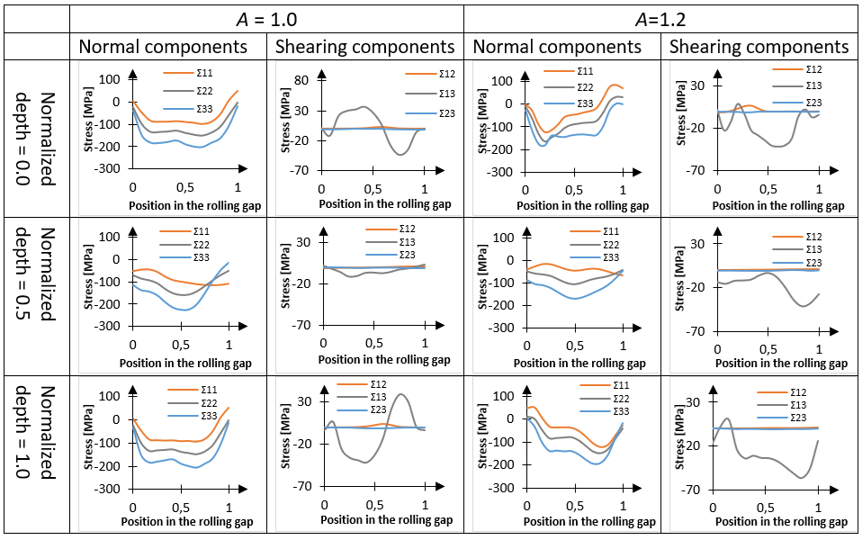
Fig. 7. Example variation of the stress tensor components, ${}_{ij}$, for symmetric (A=1.0) and asymmetric (A=1.2) rolling vs. normalized rolling gap length in the first rolling pass with the flat entry (α=0º) for three sites in the sample (0.0, 0.5 and 1.0).

The example experimental and predicted textures corresponding to A=1.2, α=0° and site 0.75 are presented in Fig. 8. The set of complete pole figures, {111}, {200},{220} and {311}, calculated from the measured uncomplete ones, is shown (Fig. 8a). A characteristic effect observed in pole figures of asymmetrically rolled materials is a lack of orthotropic symmetry, which can be approximately presented as a rotation of pole figure maxima around the transverse direction (TD) – Fig. 8a. The ODF determined from measured pole figures is presented in the Euler angles space, according to the Bunge convention ($φ_{1}$, Φ and $φ_{2}$) [43][65]) - Fig. 8b.
The examined rolling texture of aluminium contains a few components. They are (Euler angles are given in parentheses): Brass ($35°, 45°, 0°)$, Copper $(90°, 35°, 45°)$, Goss $(0°, 45°, 0°)$ and S $(59°, 37°, 63°)$ components. During symmetric or asymmetric rolling their orientations are changed. We will focus our attention on the strongest component, i.e., on Brass (B) orientation. Its four equivalent maxima, marked in the $φ_{2}=0°$ cross-section of the ODF, are shown in Fig. 9 a - they are all located at the line Φ=45$°$. When significant shear stress appears during deformation (in our case ${}_{13}$), two pairs of these maxima are shifted from the symmetry line Φ=45$°$ along axis (up or down) - cf. Figs. 9 c, d. This is also visible in $φ_{2}=0°$ cross-section in the case of experimental and simulated ODFs - Fig. 8 b and c. The amplitude and sign of this shift is defined by $β=∆$ angle, which is schematically explained in Fig. 9. It can be verified that misorientation between B orientation and its final position defined by the shift β, can be described by rotation ω≈$∆$ around the axis r close to [100] crystal direction; the reason is that $φ_{1}$ is small (a few degrees) and $φ_{2}=0°$ - cf. Fig 9 a. Let us take an example: for $∆=20°$ and $∆φ_{1}=5°$, the resulting misorientation angle is $=20.6°$ and rotation axis is [0.97, 0.20, 0.14], i.e. is close to [100] (the formula for misorientation angle and rotation axis are recalled in Appendix).
As a consequence, we will focus on the analysis of β shifts appearing at different sample depths as an indicator of texture heterogeneity/homogeneity in the rolled aluminium samples deformed with different parameters of rolling geometry.
It can be seen that the ODF predicted by CEP model is in a good agreement with the experimental one (cf. Figs 8 b and c). For both textures, the β>0 shift of texture B component appears.
Let us review now texture modifications caused by different variants of rolling geometry.

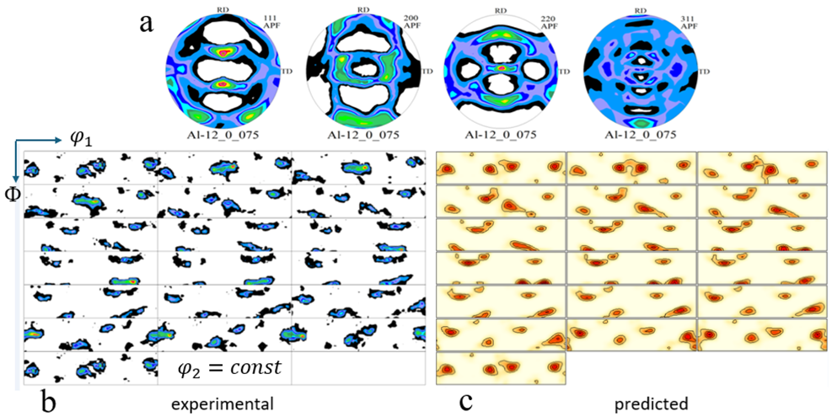
Fig. 8. Rolling texture of aluminium, A=1.2, α=0°, site 0.75: {111}, {200},{220} and {311} experimental pole figures (a), ODF recalculated from measured pole figures (b), and ODF predicted using stress field obtained from FEM and CEP deformation model (c). In the presented ODFs Euler angles ranges are: $0°≤φ_{1}≤360°$, $0°≤≤90°$ , $0°≤φ_{2}≤90°$ and cross sections at $φ_{2}=const$ with $φ_{2}=5°$ are shown.

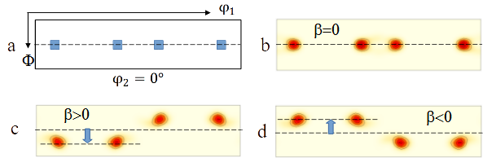
Fig. 9. a) Equivalent four maxima of Brass (B) texture component marked in the $φ_{2}=0°$ cross-section of ODF; they are located at the symmetry line at Φ=45$°$. On the remaining cross-sections model B maxima shifts ($β=∆$) from the symmetry line Φ=45$°$ are shown: b) β=0 (no shift), c) β>0 and d) β<0.

The set of experimental and predicted textures (CEP and CEVP models) after symmetric (A=1.0) and asymmetric (A=1.2) rolling, for the flat entry of the material (α=0°) is presented in Fig. 10. For the sake of brevity only characteristic $φ_{2}=0°$ ODF sections are shown. The presented textures are shown for the sites (normalized depths): 0.0, 0.25, 0.50, 0.75, 1.0. To make the effect of texture component shifts more visible, the line at $=45°$, was added in all presented $φ_{2}=0°$ cross sections. The measured textures are placed in higher rows and predicted ones - in lower ones. To enable an easier analysis of texture modifications - the calculated amplitudes and signs of texture shifts (angles β) for this and the following figures are summarized in Table 3. We note that β shifts for textures presented in Table 3 are quite important (their amplitude can reach maximally 30$°$).

The following discussion of texture component shifts is based in this section on the calculated β values. The comparison with experimental β shifts is presented in the section 5.

Table 3. Shifts of B component maxima in $φ_{2}=0°$ cross-section in the predicted textures for all studied variants of rolling geometry. The signs of β angles are marked schematically by arrows, while the values of the calculated β angles (FEM + CEVP model) are given below (they were determined with the uncertainty of ± 2.5°).
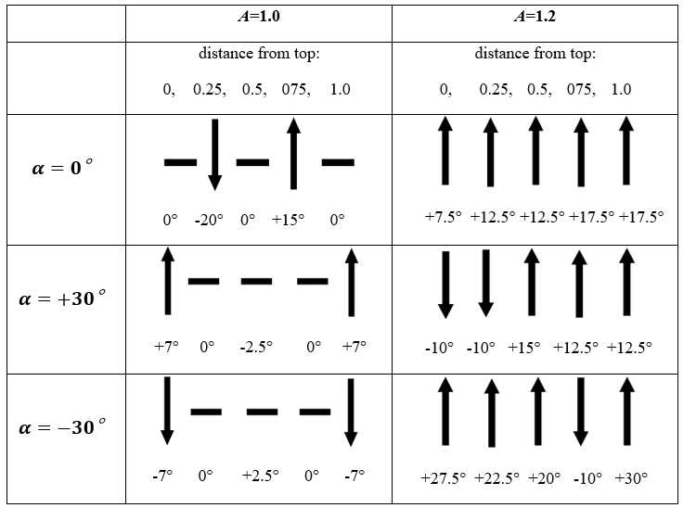

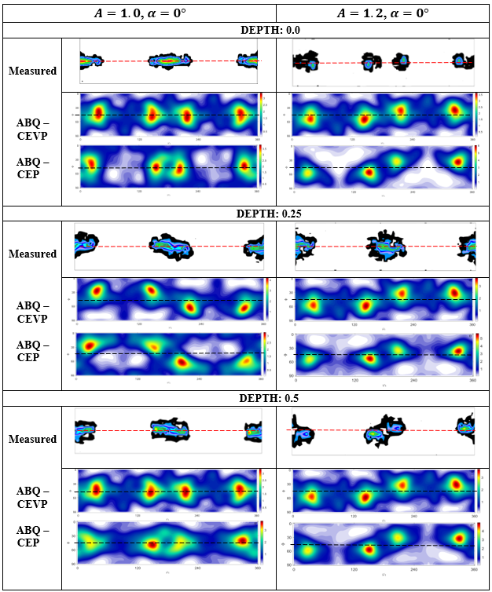
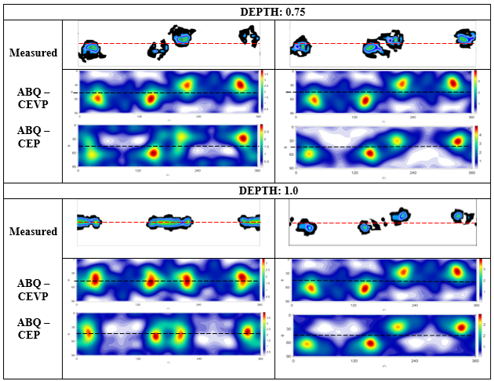
Fig. 10. Comparison of experimental and predicted ODFs (Abaqus + CEVP or CEP models), for symmetric (A=1.0) and asymmetric rolling (A=1.2), with flat entry (α=0°). ODF cross sections at $φ_{2}=0°$ are shown for the sites: 0.0, 0.25, 0.50, 0.75 and 1.0. The intensities of texture maxima are close to 5.

The results presented in Fig. 10 show that textures, with flat material entry, after symmetric and asymmetric rolling are different. In the case of symmetric rolling (A=1.0), texture maxima shift (β=0°) do not appear on both sample surfaces and in the middle of it (i.e., sites 0.0, 0.5 and 1.0). In contrast a negative shift (β<0) occurs at the site 0.25, and a positive one (β>0) at the site 0.75. On the other hand, in the case of asymmetric rolling (A=1.2) positive shifts (β>0) are observed at all examined sample depths. This result confirms that the selected rolling asymmetry homogenizes the texture across the sample depth.
Another observation is that textures predicted by two used crystalline models (CEP and CEVP) are very similar to each other and close to the experimental ones. Despite different formulations of grain-material interaction in these models, the same signs and similar amplitudes of texture maxima shifts are predicted. This result can be explained by the fact that the main factor determining the lattice rotation is the evolution of strain in slip systems, which depends on the stress/strain field well predicted by FEM. Taking into account, that very similar texture are predicted by two models, only the results obtained with CEVP one are presented in the following figures.

Comparison of experimental and calculated textures after rolling with A=1.0 for flat and tilted entries into the rolling gap (α=0° and α=30°) is presented in Figure 11. Also, in this case a general agreement between the predicted and experimental textures can be seen. On the upper and lower surface of the rolled strip (sites 0.0 and 1.0) a small positive shift (β=7°) appear for the insertion angle α=30°, while for α=0° there are no shifts in these sites. In the middle of the strip depth (site 0.5) the results for α=0° and for α=30°are similar with insignificant shifts in the texture maxima. It can be also noted that for α=30°, at the depths of 0.25 and 0.75 the shifts of the texture maxima disappear, while in the case of flat entry there are strong shifts at these sites (β= –20° and β=+15°, respectively). Finally, it can be stated that in the case of rolling with A=1.0, the tilted entry (α=30°) leads to a more homogeneous texture inside the rolled bar as compared to the flat entry one (α=0°) – cf. Table 3. Results obtained with the CEVP model in the case of rolling with A=1.0 showed that the effects on β angles for the α= –30° and α=30° tilted entries are exactly opposite. This can be seen in Table 3.

Finally, Fig. 12 presents predicted and experimental textures for the samples after asymmetric rolling (A=1.2) for three values of the insertion angle α: 0°, 30° and –30° for the material layers situated at the positions: 0.0, 0.25, 0.50, 0.75, 1.0. Again, despite small discrepancies between the predicted and experimental textures, the general trends of the shifts in the texture maxima are correctly predicted. As already mentioned, a homogeneous texture distribution is obtained for the flat entry (β>0 in all sites). In the cases of the entry angle α equal to 30° we observe negative β shifts in two upper sites and positive ones in three remaining sites; therefore, we can call this distribution in β shifts as ‘the sandwich type’. On the other hand, when comparing textures for opposite signs of α angle (30° and –30°), the opposite signs β angle appear for the layers 0,0, 0.25 and 0.75 but the same signs of texture shifts are observed for the layers 0.5 and 1.0. It can be also noted that β shifts have important amplitudes (between 20° and 30°) in the case of downward entry (α= –30°). It can be also noted that texture is more homogeneous for the entry angle α= –30° than for α=30°.

In view of the obtained results, it can be noted that use of tilted sheet entry, together with the asymmetry parameter ($A=d_{2}/d_{1}$), can strongly modify texture heterogeneity/homogeneity characterized by the variation of β angle vs. depth in the rolled strip.

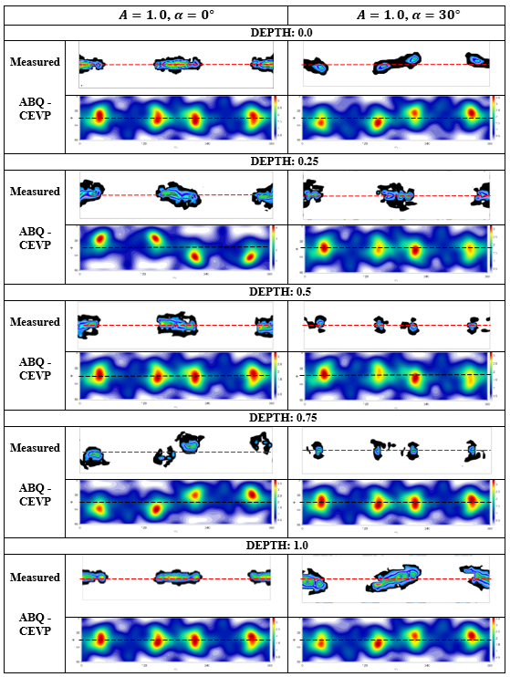
Fig. 11. Comparison of experimental and predicted ODFs (Abaqus + CEVP model) for symmetric rolling (A=1.0) for two insertion angles: α=0° and α=30°. The ODF cross sections at $φ_{2}=0°$ are presented. Results for sites: 0.0, 0.25, 0.50, 0.75 and 1.0 are shown. The intensities of texture maxima are close to 5.

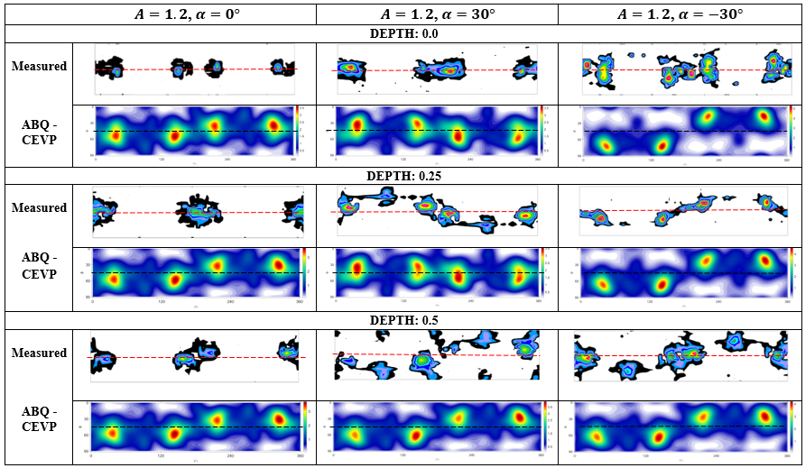
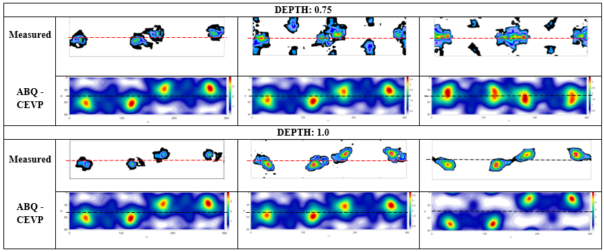
Fig. 12. Comparison of experimental and predicted ODFs (Abaqus + CEVP model) for asymmetric rolling (A=1.2) for the insertion angles: α=0°, α=30°and α= –30°. The ODF cross sections at $φ_{2}=0°$ are presented. Results for sites: 0.0, 0.25, 0.50, 0.75 and 1.0 are shown. The intensities of texture maxima are close to 5.

- Discussion

The presented results confirm the modifications of texture, resulting as β shifts of B texture maxima in the ODF $φ_{2}=0$ cross-section, in function of the asymmetry rolling parameter A and the angle α of material entry into the rolling gap. It turned out that key stress components (${}_{13}$, ${}_{33} and {}_{11})$ determine β values and signs. As already considered, the effects of the studied rolling process parameters can be summarized basing on the Table 3. Let us review the results in function of the angle α of material entry into the rolling gap.
The experimental and predicted β shifts vs. depth in the rolled strip for the examined rolling geometries are presented in Fig. 13. As can be seen, the predicted β shifts have higher amplitudes than the experimental ones, however, types of their variations are similar.
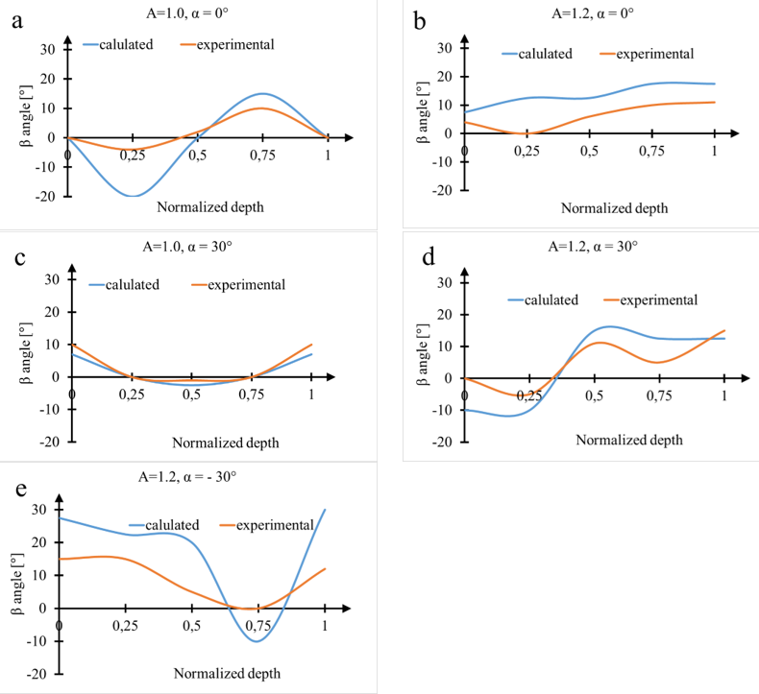
Fig. 13. β shift in function of relative depth in the cases of: flat material entry: a) symmetric rolling (A=1.0), b) asymmetric rolling (A=1.2); tilted material entry: c) symmetric rolling, A=1.0, α=30°, d) asymmetric rolling, A=1.2, α= 30°, e) asymmetric rolling, A=1.2, α= –30°).

Consider first the flat entry of the rolled strip into rolling gap (α=0°). In the case of symmetric rolling, A=1.0, (Fig. 13a) texture rotation does not occur on both rolled surfaces and in the middle of the rolled strip thickness, but it appears (with opposite signs) at sites 0.25 and 0.75. Thus, texture distribution vs. product thickness is inhomogeneous. On the other hand, during asymmetric rolling, A=1.2 (Fig. 13b), the positive texture maxima shift (β>0) appears homogeneously in all examined sites. Therefore, the asymmetric rolling with flat entry causes important texture homogenisation and it can be used for this purpose in the technological practice.
In the case of thirty-degree entries also characteristic effects were observed. For upward entry (α=30°) of the sample rolled with A=1.0, small positive shifts of texture maxima on both product surfaces (sites 0.0 and 1.0) and practically no shift in its interior (sites 0.25, 0.50, 0.75) were developed - Fig. 14 c; thus, texture is nearly homogeneous, contrary to the case of classical rolling with flat entry. It should be mentioned that the downward entry (α= –30°) in the case of A=1.0 only reverses the signs of β shifts thus, the obtained texture is again nearly homogeneous. This result is understandable due to the symmetry in the rolling process with A=1.0.

In contrast, the thirty-degree entries (α=30° and α= –30°) in the case of asymmetrically rolled sample (A=1.2), produce textures with much higher variations in β. In the case of upward tilt entry, i.e., towards the smaller roll (α=30°), a heterogeneous texture is obtained, in which β distribution can be called ‘the sandwich’ type - Fig. 14 d. In contrast, the downward tilt entry, i.e., towards the bigger roll (α= –30°), leads to positive signs of β at all product sites in the experimental texture (a negative β appears only at site 0.75 in the predicted texture) - Fig. 14 e; thus, this experimental texture can be considered as ‘quasi homogeneous’ in the sense that β is positive across the rolled sample thickness.

- Conclusions
Measurements and simulations of rolling textures of aluminium were carried out, assuming two parameters inducing rolling asymmetry: the difference in the diameters of cooperating rolls and the angle of the material insertion into the rolling gap. The predicted textures are in good agreement with the experimentally determined ones. The texture modifications are mainly caused by the shear stress component ${}_{13}$ (and also by ${}_{11}-{}_{33}$ difference), generated during asymmetric rolling. Despite minor discrepancies the main trends, in particular the occurrence and direction of B component maxima shifts, are correctly predicted by the calculation results. Thus, it can be stated that the Finite Element method calculations, combined with the crystalline deformation models used, correctly describe the studied rolling processes. It was found that despite differences in formulation of two crystalline models (CEP and CEVP), the predicted texture shifts are very similar, which confirms the predominant influence of rolling geometry and crystal symmetry on crystal lattice rotation. This indicates that for practical purposes it is quite sufficient to use a relatively simple CEP model, which requires much less computational resources.
Let us shortly summarize now the effects of applied rolling parameters:
1) When flat entry of the rolled strip between rolls (α=0$°$) is applied:
a) symmetric rolling (A=1.0) leads to a heterogeneous texture (with variable sign of texture maxima shifts, β, on the rolled strip thickness),
b) asymmetric rolling (A=1.2) produces a homogeneous texture with β>0. This implies a homogeneous strain and stress distribution on the rolled bar thickness. Consequently, such rolling asymmetry can be recommended to the technological practice.

2) When rolled strip entry is upward inclined (entry with α=30°):
a) in the case of A=1.0 – a nearly homogeneous texture, with small positive values of β is obtained. Such process can be also recommended to the technological practice, but its application can be more difficult.
b) in the case of A=1.2 - a heterogeneous texture with variable sign of β angle on the rolled strip thickness is obtained; this distribution is of ‘sandwich type’,

3) When the rolled strip is tilted towards the bigger roll (i.e., downward inclined entry with
α= –30°):
a) in the case of A=1.0 a nearly homogeneous texture, with small negative values of β is obtained. This geometry can be also recommended and by symmetry is analogous to the case 2a ( tilted entry with α=30°),
b) in the case of A=1.2 a partly homogeneous texture with β of the same sign in four sites on the rolled strip thickness.is obtained.

Consequently, two cases can be distinguished in aspect of obtaining homogeneous texture distribution across the sample width: A=1.2 with α=0$°$ and A=1.0 with α=30°.
Finally, as an important result, it can be concluded that rolling with tilted entry of the material strip between rolls, both in the cases of symmetric and asymmetric rolling (A=1.0 and A=1.2), can be used to enhance the texture homogeneity vs. the rolled strip thickness. A manufacturer. Therefore, has some flexibility in selecting the optimal combination.

Acknowledgments:
This work was financed by a grant from the National Science Centre, Poland (NCN), No. UMO-2023/49/B/ST11/00774.
We gratefully acknowledge Polish high-performance computing infrastructure PLGrid (HPC Center: ACK Cyfronet AGH) for providing computer facilities and support within computational grant no. PLG/2023/016602.
Disclosure statement
No potential conflict of interest was reported by the authors.

Data availability:
The raw and processed data required to reproduce these findings can be downloaded from https://doi.org/10.58032/AGH/SQEVDB

References
[1] G. Vincze, F. Simões, and M. Butuc, ‘Asymmetrical rolling of aluminum alloys and steels: A review’, 2020. doi: 10.3390/met10091126.
[2] J. Kraner, T. Smolar, D. Volsak, P. Cvahte, M. Godec, and I. Paulin, ‘A REVIEW OF ASYMMETRIC ROLLING OSNOVNI PREGLED ASIMETRIČNEGA VALJANJA’, Materiali in Tehnologije, vol. 54, no. 5, 2020, doi: 10.17222/mit.2020.158.
[3] D. Bozkaya and P.R. Jepson, ‘Methods and apparatus for controlling texture of plates and sheets by tilt rolling, US patent No 8,250,895 B2’, 8,250,895 B2, Aug. 28, 2012
[4] S. H. Kim, J. H. Ryu, K. H. Kim, and D. N. Lee, ‘The evolution of shear deformation texture and grain refinement in asymmetrically rolled aluminum sheets’, Materials Science Research International, vol. 8, no. 1, 2002, doi: 10.2472/jsms.51.3appendix_20.
[5] W. Polkowski, P. Jóźwik, M. Polański, and Z. Bojar, ‘Microstructure and texture evolution of copper processed by differential speed rolling with various speed asymmetry coefficient’, Materials Science and Engineering A, vol. 564, 2013, doi: 10.1016/j.msea.2012.12.006.
[6] S. Ucuncuoglu, A. Ekerim, G. O. Secgin, and O. Duygulu, ‘Effect of asymmetric rolling process on the microstructure, mechanical properties and texture of AZ31 magnesium alloys sheets produced by twin roll casting technique’, Journal of Magnesium and Alloys, vol. 2, no. 1, pp. 92–98, 2014, doi: 10.1016/j.jma.2014.02.001.
[7] A. Wauthier, H. Regle, J. Formigoni, and G. Herman, ‘The effects of asymmetrical cold rolling on kinetics, grain size and texture in IF steels’, Mater Charact, vol. 60, no. 2, pp. 90–95, 2009, doi: 10.1016/j.matchar.2008.07.004.
[8] B. Beausir, S. Biswas, D. I. Kim, L. S. Tóth, and S. Suwas, ‘Analysis of microstructure and texture evolution in pure magnesium during symmetric and asymmetric rolling’, Acta Mater, vol. 57, no. 17, pp. 5061–5077, 2009, doi: 10.1016/j.actamat.2009.07.008.
[9] A. Uniwersał, M. Wroński, M. Wróbel, K. Wierzbanowski, and A. Baczmański, ‘Texture effects due to asymmetric rolling of polycrystalline copper’, Acta Mater, vol. 139, 2017, doi: 10.1016/j.actamat.2017.07.062.
[10] M. Y. Amegadzie and D. P. Bishop, ‘Effect of asymmetric rolling on the microstructure and mechanical properties of wrought 6061 aluminum’, Mater Today Commun, vol. 25, 2020, doi: 10.1016/j.mtcomm.2020.101283.
[11] S. Dutta and M. S. Kaiser, ‘EFFECT OF ASYMMETRIC ROLLING ON FORMABILITY OF PURE ALUMINIUM’, Journal of Mechanical Engineering, vol. 44, no. 2, 2015, doi: 10.3329/jme.v44i2.21432.
[12] B. H. Cheon, H. W. Kim, and J. C. Lee, ‘Asymmetric rolling of strip-cast Al-5.5Mg-0.3Cu alloy sheet: Effects on the formability and mechanical properties’, Materials Science and Engineering A, vol. 528, no. 15, pp. 5223–5227, 2011, doi: 10.1016/j.msea.2011.03.021.
[13] H. Yu et al., ‘Mechanical properties and microstructure of a Ti-6Al-4V alloy subjected to cold rolling, asymmetric rolling and asymmetric cryorolling’, Materials Science and Engineering: A, vol. 710, 2018, doi: 10.1016/j.msea.2017.10.075.
[14] G. Herman et al., Metallurgical impact of hot asymmetric rolling. Luxembourg: Final Report of the European Commission Research for Coal and Steel, Contract no RFSR-CT-2003-00040, 2008.
[15] D. Pustovoytov, A. Pesin, and P. Tandon, ‘Asymmetric (Hot, warm, cold, cryo) rolling of light alloys: A review’, 2021. doi: 10.3390/met11060956.
[16] S. Wronski, M. Wrobel, A. Baczmanski, and K. Wierzbanowski, ‘Effects of cross-rolling on residual stress, texture and plastic anisotropy in f.c.c. and b.c.c. metals’, Mater Charact, vol. 77, pp. 116–126, 2013, doi: 10.1016/j.matchar.2013.01.005.
[17] A. Babapour, S. J. Hosseinipour, R. Jamaati, and M. Abbasi, ‘Effects of Asymmetric Cross-Rolling and Initial Annealing on the Microstructure, Crystallographic Texture, and Magnetic Behavior of Silicon Steel with Different Amounts of Antimony’, J Mater Eng Perform, vol. 32, no. 18, 2023, doi: 10.1007/s11665-022-07703-6.
[18] F. Goli and R. Jamaati, ‘Asymmetric cross rolling (ACR): A novel technique for enhancement of Goss/Brass texture ratio in Al-Cu-Mg alloy’, Mater Charact, vol. 142, pp. 352–364, 2018, doi: 10.1016/j.matchar.2018.06.004.
[19] A. Uniwersał, M. Wróbel, K. Wierzbanowski, S. Wroński, and A. Baczmański, ‘Mechanical and microstructural characteristics of polycrystalline copper rolled asymmetrically to a high deformation level’, Mater Charact, vol. 148, pp. 214–223, 2019, doi: 10.1016/j.matchar.2018.12.017.
[20] Q. Zhao, X. Hu, and X. Liu, ‘Analysis of Mechanical Parameters in Multi-Pass Asymmetrical Rolling of Strip by Slab Method’, Materials, vol. 16, no. 18, 2023, doi: 10.3390/ma16186286.
[21] S. B. Diniz, E. A. Benatti, A. Dos Santos Paula, R. E. Bolmaro, L. C. Da Silva, and B. G. Meirelles, ‘Microstructural evaluation of an asymmetrically rolled and recrystallized 3105 aluminum alloy’, 2016. doi: 10.1016/j.jmrt.2016.02.001.
[22] M. Qwamizadeh, M. Kadkhodaei, and M. Salimi, ‘Asymmetrical sheet rolling analysis and evaluation of developed curvature’, International Journal of Advanced Manufacturing Technology, vol. 61, no. 1–4, pp. 227–235, 2012, doi: 10.1007/s00170-011-3697-4.
[23] F. Farhatnia and M. Salimi, ‘Effect of entry bending moment on exit curvature in asymmetrical rolling’, International Journal of Engineering, Science and Technology, vol. 3, no. 4, 2011, doi: 10.4314/ijest.v3i4.68550.
[24] R. Yekta, H. Zohoor, and A. Motekallem, ‘Analysis of asymmetric cold rolling using finite-element method for creating at sheet’, Scientia Iranica, vol. 25, no. 6B, 2018, doi: 10.24200/sci.2018.20735.
[25] H. Su, L. Hou, Q. Tian, Y. Wang, and L. Zhuang, ‘Flattening aluminum plates with tuning asymmetric rolling parameters’, Journal of Materials Research and Technology, vol. 27, 2023, doi: 10.1016/j.jmrt.2023.11.204.
[26] K. H. Kim and D. N. Lee, ‘Analysis of deformation textures of asymmetrically rolled aluminum sheets’, Acta Mater, vol. 49, no. 13, 2001, doi: 10.1016/S1359-6454(01)00036-2.
[27] S. H. Lee and D. N. Lee, ‘Analysis of deformation textures of asymmetrically rolled steel sheets’, Int J Mech Sci, 2001, doi: 10.1016/S0020-7403(01)00025-X.
[28] J. Liu and R. Kawalla, ‘Influence of asymmetric hot rolling on microstructure and rolling force with austenitic steel’, Transactions of Nonferrous Metals Society of China (English Edition), vol. 22, no. SUPPL.2, 2012, doi: 10.1016/S1003-6326(12)61753-1.
[29] M. Wronski, K. Wierzbanowski, S. Wronski, B. Bacroix, and P. Lipinski, ‘Texture variation in asymmetrically rolled titanium. Study by Finite Element Method with implemented crystalline model’, Int J Mech Sci, vol. 87, pp. 258–267, 2014, doi: 10.1016/j.ijmecsci.2014.06.010.
[30] H. Solouki, R. Jamaati, and H. Jamshidi Aval, ‘Comparison of a copper processed by asymmetric unidirectional rolling (AUR) and cross rolling (ACR): Strain distribution, microstructure, texture, and mechanical properties’, Mater Chem Phys, vol. 311, 2024, doi: 10.1016/j.matchemphys.2023.128558.
[31] F. Zhang, G. Vincent, Y. H. Sha, L. Zuo, J. J. Fundenberger, and C. Esling, ‘Experimental and simulation textures in an asymmetrically rolled zinc alloy sheet’, Scr Mater, vol. 50, no. 7, 2004, doi: 10.1016/j.scriptamat.2003.12.031.
[32] D. Solas, S. Chhann, T. Baudin, and R. Penelle, ‘Texture and microstructure of invar® deformed by asymmetrical rolling’, in Materials Science Forum, 2010. doi: 10.4028/www.scientific.net/MSF.636-637.538.
[33] G. Stradomski et al., ‘Influence of Asymmetric Rolling Process on the Microstructure Properties of Bimetallic Sheet Metals’, Materials, vol. 15, no. 6, 2022, doi: 10.3390/ma15062013.
[34] Z. Li, L. Fu, B. Fu, and A. Shan, ‘Effects of annealing on microstructure and mechanical properties of nano-grained titanium produced by combination of asymmetric and symmetric rolling’, Materials Science and Engineering: A, vol. 558, 2012, doi: 10.1016/j.msea.2012.08.005.
[35] T. E. Buchheit, E. Cerreta, L. Deibler, S.-R. Chen, and J. R. Michael, ‘Characterization of Tri-lab Tantalum (Ta) plate, Sandia Report SAND2014-17645’, Albuquerque, Aug. 2014.
[36] K. Wierzbanowski, M. Wroński, and T. Leffers, ‘FCC rolling textures reviewed in the light of quantitative comparisons between simulated and experimental textures’, Critical Reviews in Solid State and Materials Sciences, vol. 39, no. 6, pp. 391–422, Nov. 2014, doi: 10.1080/10408436.2014.899485.
[37] P. Zattarin, A. Baczmański, P. Lipiński, and K. Wierzbanowski, ‘Modified self consistent model for time independent plasticity of polycrystalline material’, Archives of Metallurgy, vol. 45, no. 2, 2000.
[38] P. R. Dawson and E. B. Marin, ‘Computational Mechanics for Metal Deformation Processes Using Polycrystal Plasticity’, Advances in Applied Mechanics, vol. 34, no. C, 1997, doi: 10.1016/S0065-2156(08)70320-X.
[39] E. B. Marin and P. R. Dawson, ‘On modelling the elasto-viscoplastic response of metals using polycrystal plasticity’, Comput Methods Appl Mech Eng, vol. 165, no. 1–4, 1998, doi: 10.1016/S0045-7825(98)00034-6.
[40] P. O. K.Pawlik, ‘Introduction to LaboTex’, 2011.
[41] ‘Software for Texture Analysis: “LaboTex”, LaboSoft, Krakow, Poland, 2014. office@labosoft.com.pl’.
[42] J. Tarasuk, K. Wierzbanowski, and A. Baczmański, ‘New algorithm of direct method of texture analysis’, Crystal Research and Technology, vol. 33, no. 1, 1997.
[43] H. J. Bunge, Texture Analysis in Material Science. London: Butterworths, 1982.
[44] A. Graça and G. Vincze, ‘A short review on the finite element method for asymmetric rolling processes’, 2021. doi: 10.3390/met11050762.
[45] R. Rakshit, B. S. Katiyar, C. N. Tomé, S. K. Panda, and S. Mandal, ‘A finite element coupled visco-plastic self-consistent simulation to predict micro-texture and anisotropy evolution during single point incremental forming in Al-Li alloy’, J Mater Process Technol, vol. 312, 2023, doi: 10.1016/j.jmatprotec.2022.117834.
[46] J. Galán, P. Verleysen, and R. A. Lebensohn, ‘An improved algorithm for the polycrystal viscoplastic self-consistent model and its integration with implicit finite element schemes’, Model Simul Mat Sci Eng, vol. 22, no. 5, 2014, doi: 10.1088/0965-0393/22/5/055023.
[47] R. A. Lebensohn and G. R. Canova, ‘A self-consistent approach for modelling texture development of two-phase polycrystals: Application to titanium alloys’, Acta Mater, vol. 45, no. 9, 1997, doi: 10.1016/S1359-6454(97)00067-0.
[48] F. Wagner, G. Canova, P. van Houtte, and A. Molinari, ‘Comparison of Simulated and Experimental Deformation Textures for BCC Metals’, Texture, Stress, and Microstructure, vol. 14, no. 1, 1991, doi: 10.1155/tsm.14-18.1135.
[49] M. Berveiller and A. Zaoui, ‘An extension of the self-consistent scheme to plastically-flowing polycrystals’, J Mech Phys Solids, vol. 26, no. 5–6, 1978, doi: 10.1016/0022-5096(78)90003-0.
[50] P. Franciosi, M. Berveiller, and A. Zaoui, ‘Latent hardening in copper and aluminium single crystals’, Acta Metallurgica, vol. 28, no. 3, 1980, doi: 10.1016/0001-6160(80)90162-5.
[51] R. A. Lebensohn and A. Needleman, ‘Numerical implementation of non-local polycrystal plasticity using fast Fourier transforms’, J Mech Phys Solids, vol. 97, 2016, doi: 10.1016/j.jmps.2016.03.023.
[52] L. S. Tóth, A. Molinari, and Y. Estrin, ‘Strain hardening at large strains as predicted by dislocation based polycrystal plasticity model’, J Eng Mater Technol, vol. 124, no. 1, 2002, doi: 10.1115/1.1421350.
[53] S. Papanikolaou, Y. Cui, and N. Ghoniem, ‘Avalanches and plastic flow in crystal plasticity: An overview’, 2018. doi: 10.1088/1361-651X/aa97ad.
[54] K. Romanov, A. Shveykin, and P. Trusov, ‘Advanced Statistical Crystal Plasticity Model: Description of Copper Grain Structure Refinement during Equal Channel Angular Pressing’, Metals (Basel), vol. 13, no. 5, 2023, doi: 10.3390/met13050953.
[55] E. B. Marin and P. R. Dawson, ‘Elastoplastic finite element analyses of metal deformations using polycrystal constitutive models’, Comput Methods Appl Mech Eng, vol. 165, no. 1–4, 1998, doi: 10.1016/S0045-7825(98)00033-4.
[56] ‘https://www.cavs.msstate.edu/icme/Mesoscale/’.
[57] S. Mercier and A. Molinari, ‘Homogenization of elastic-viscoplastic heterogeneous materials: Self-consistent and Mori-Tanaka schemes’, Int J Plast, vol. 25, no. 6, 2009, doi: 10.1016/j.ijplas.2008.08.006.
[58] S. Groh, E. B. Marin, M. F. Horstemeyer, and H. M. Zbib, ‘Multiscale modeling of the plasticity in an aluminum single crystal’, Int J Plast, vol. 25, no. 8, 2009, doi: 10.1016/j.ijplas.2008.11.003.
[59] F. Roters, P. Eisenlohr, L. Hantcherli, D. D. Tjahjanto, T. R. Bieler, and D. Raabe, ‘Overview of constitutive laws, kinematics, homogenization and multiscale methods in crystal plasticity finite-element modeling: Theory, experiments, applications’, Acta Mater, vol. 58, no. 4, 2010, doi: 10.1016/j.actamat.2009.10.058.
[60] X. Wang, W. Wu, M. Zhan, Z. Zheng, Z. Li, and T. Liu, ‘Analysis of the texture evolution during multipass tube spinning of a TA15 alloy using the crystal plasticity finite element model’, Journal of Materials Research and Technology, vol. 27, 2023, doi: 10.1016/j.jmrt.2023.11.087.
[61] O. Lypchanskyi et al., ‘Temperature dependent deformation behavior and texture evolution in AA6082 aluminum alloy: An integrated experimental and crystal plasticity simulation approach’, Int J Plast, vol. 176, 2024, doi: 10.1016/j.ijplas.2024.103942.
[62] R.K., ‘Plasticity of Crystals. E. Schmid and W. Boas. F. A. Hughes & Co. Ltd., London. 1950. 353 pp. 222 illustrations. Index. Appendix. Bibliography. 35s. net.’, The Journal of the Royal Aeronautical Society, vol. 54, no. 479, 1950, doi: 10.1017/s0368393100116219.
[63] T. Leffers, ‘Computer simulation of the plastic deformation in face‐centred cubic polycrystals and the rolling texture derived’, physica status solidi (b), vol. 25, no. 1, 1968, doi: 10.1002/pssb.19680250133.
[64] R.V. Mises, ‘Mechanik der plastischen Formaenderung von Kristallen’, Z. Angew. Math. Mech., vol. 8, pp. 161–185, 1928.
[65] J. Hansen, J. Pospiech, and K. Lücke, Tables for Texture Analysis of Cubic Crystals. 1978. doi: 10.1007/978-3-662-01630-5.

APPENDIX: Calculation of rotation axis and angle between two orientations

Consider two cubic crystal orientations, $a_{A}$ and $a_{B}$ , where each orientation matrix $a$ is expressed by Euler angles $φ_{1}$, Φ, $φ_{2}$ :
$$a=\left[\begin{matrix}\cos{φ_{1}\cos{φ_{2}-\sin{φ_{1}}}}\sin{φ_{2}\cos{}} & \sin{φ_{1}\cos{φ_{2}}+}\cos{φ_{1}}\sin{φ_{2}\cos{}} & \sin{φ_{2}}\sin{} \\ -\cos{φ_{1}}\sin{φ_{2}}-\sin{φ_{1}}\cos{φ_{2}\cos{}} & -\sin{φ_{1}}\sin{φ_{2}}+\cos{φ_{1}}\cos{φ_{2}}\cos{} & \cos{φ_{2}}\sin{} \\ \sin{φ_{1}}\sin{} & -\cos{φ_{1}}\sin{} & \cos{}\end{matrix}\right]$$
(A1)
The misorientation matrix $g$ between orientations, $a_{B}$ and $a_{A}$ is calculated as:
$$g=a_{A }a_{B}^{-1}$$ | (A2)
The misorienation angle, ω, is done by:
$$\cos{}= \frac{trace \left[g\right]-1}{2}$$ | (A3)
The components of rotation axis are given by:
$$d_{1}=\frac{g_{23}-g_{32}}{2\sqrt{1-{(cos{)}}^{2}}} ,$$ | $$d_{2}=\frac{a_{31}-a_{13}}{2\sqrt{1-{(cos{)}}^{2}}}$$ | $$d_{3}=\frac{g_{12}-g_{21}}{2\sqrt{1-{(cos{)}}^{2}}}$$
(A4)
The above procedure has to be repeated next for all symmetrically equivalent rotation axes (24 symmetry elements in the case of cubic crystals) and the solution with the minimal ω angle should be retained.

